Recreating Flags In App Lab
Now that we have gone though one example of recreating the country of Bangladesh’s flag I would like you to complete some more flags in app lab. You may with work with a partner on this if you choose just be sure to leave in the comments who you worked with. Just 1 other person though.
Requirements…
- Flags should be created in the full turtle API level that you just did the extension in.
- Flags should use either RGB or Hex Code values for their colors (you will need to look this information up)
- Flags do not have to fill up the whole app lab screen you could do them smaller in the middle of the screen and leave white edges at the top if you choose
- Must do either all 2 flags from group A or 1 flag from group B
- Must choose another countries flag of your choosing and complete it

Group A (easier) *2 of 3*
Switzerland
Romania
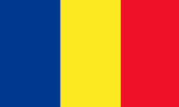

United Arab Emirates
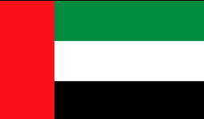

Group B (harder) *only 1*
United States
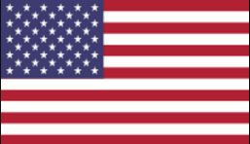
*You do not need 50 stars just 5-10 will be fine*
Kuwait
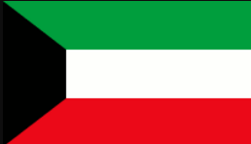

Norway
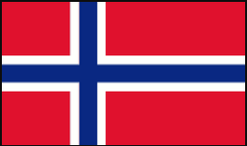

*Please click open on the side of the assignment to get your submission document*

