Muddy City (csunplugged.com)
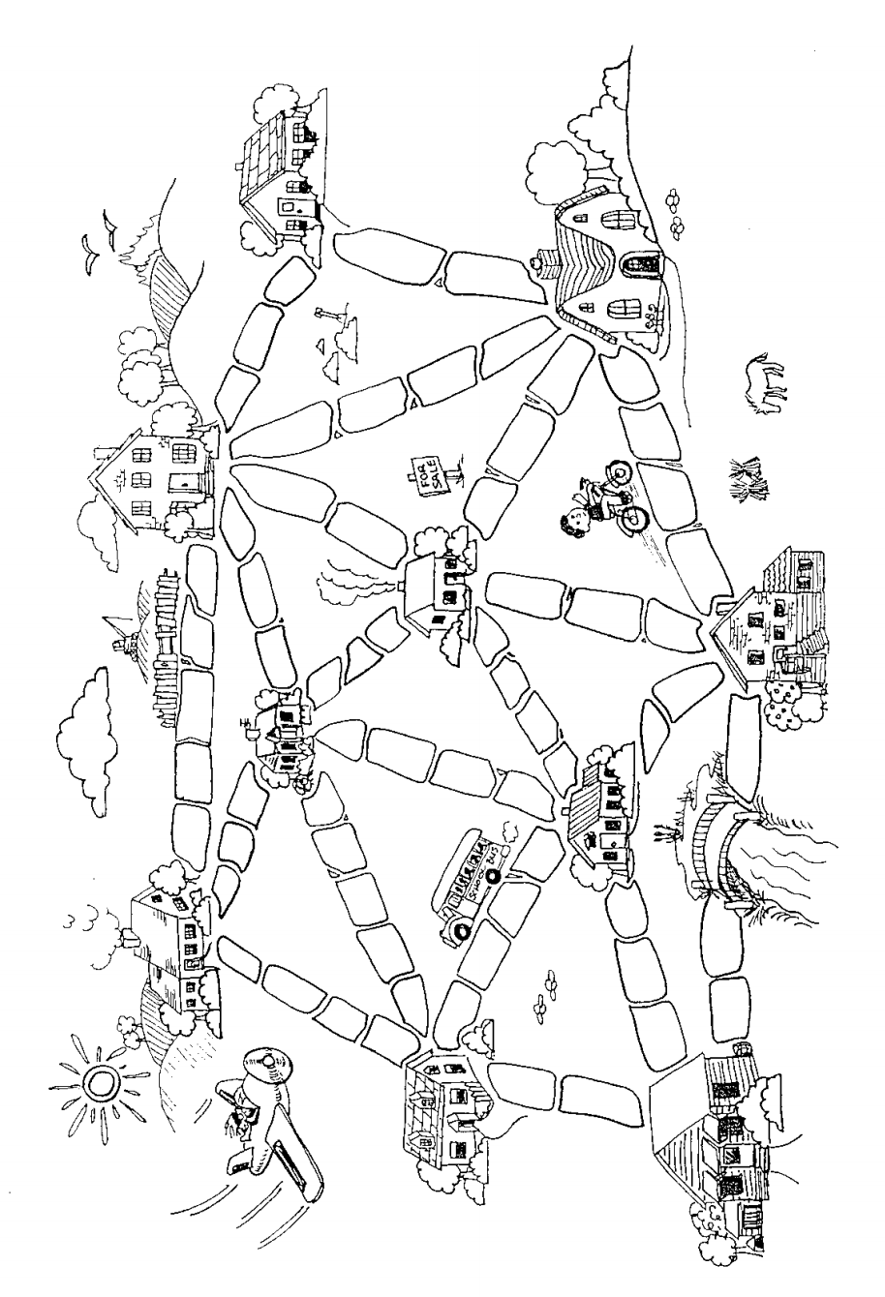
Instructions: Find the minimum number of paving stones that need to be used so that you can get from any house to any other house. (The bridge doesn’t need to be paved.)

Muddy City (csunplugged.com)
Instructions: Find the minimum number of paving stones that need to be used so that you can get from any house to any other house. (The bridge doesn’t need to be paved.)

