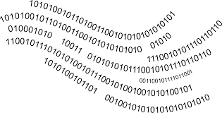

Binary Number System Notes & Practice

Computers use binary numbers to store and process information. Binary numbers are made up of binary digits, each digit is called a **BIT**, taken from the words **BI-nary digi-T**. The binary system uses only two symbols, 0 or 1. Binary numbers are like decimal numbers except they are in a base of 2 instead of base of 10. Binary code can be used to represent numbers, letters, pictures, and sound. A **byte** is made up of 8 bits.

|  |  |  |  |  |  |  |  |
| --- | --- | --- | --- | --- | --- | --- | --- |
| **27** | **26** | **25** | **24** | **23** | **22** | **21** | **20** |
| **128** | **64** | **32** | **16** | **8** | **4** | **2** | **1** |

**If value = 1**, then it is **true (or light is turned “on”)**

**If value = 0**, then it is **false** **(or light is turned “off”)** --the number assigned **should not** be added to the total.

How can you tell quickly if a binary number is odd or even? If the first bit is 0, then the binary number is even.

### **Example 1: Convert to binary numbers Example 2: Convert to decimal numbers**

1. 12 = ________________ 6. 0000 1101 = ___________

2. 75 = ________________ 7. 0001 0101 = ___________

3. 100 = ________________ 8. 0000 0101 = ___________

4. 122 = ________________ 9. 0000 1111 = ___________

5. 38 = ________________ 10. 0100 0110 = ___________