Instructions | Instructions | 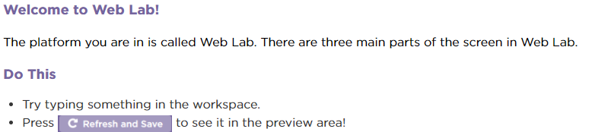
Speaker | reads instructions aloud
Files | where you save your html and image files
Workspace | where you type in your html tag code
Preview | where you can see your website
Inspector | allows you to find sections of the html code easily
Documentation | A directory of html tags
Version History | See a history of all you’ve done. Reset to beginning if you want.
Refresh and Save | Runs your program
Progress Bar | Shows where you are in the course
Finish | After completing the lesson

Student Names ________________________________________________ www.code .org CSDiscoveries Unit 2 Web Design
Directions: In the table on the sheets provided, cut out the parts of the interface along the dotted lines. Paste them below where they belong.

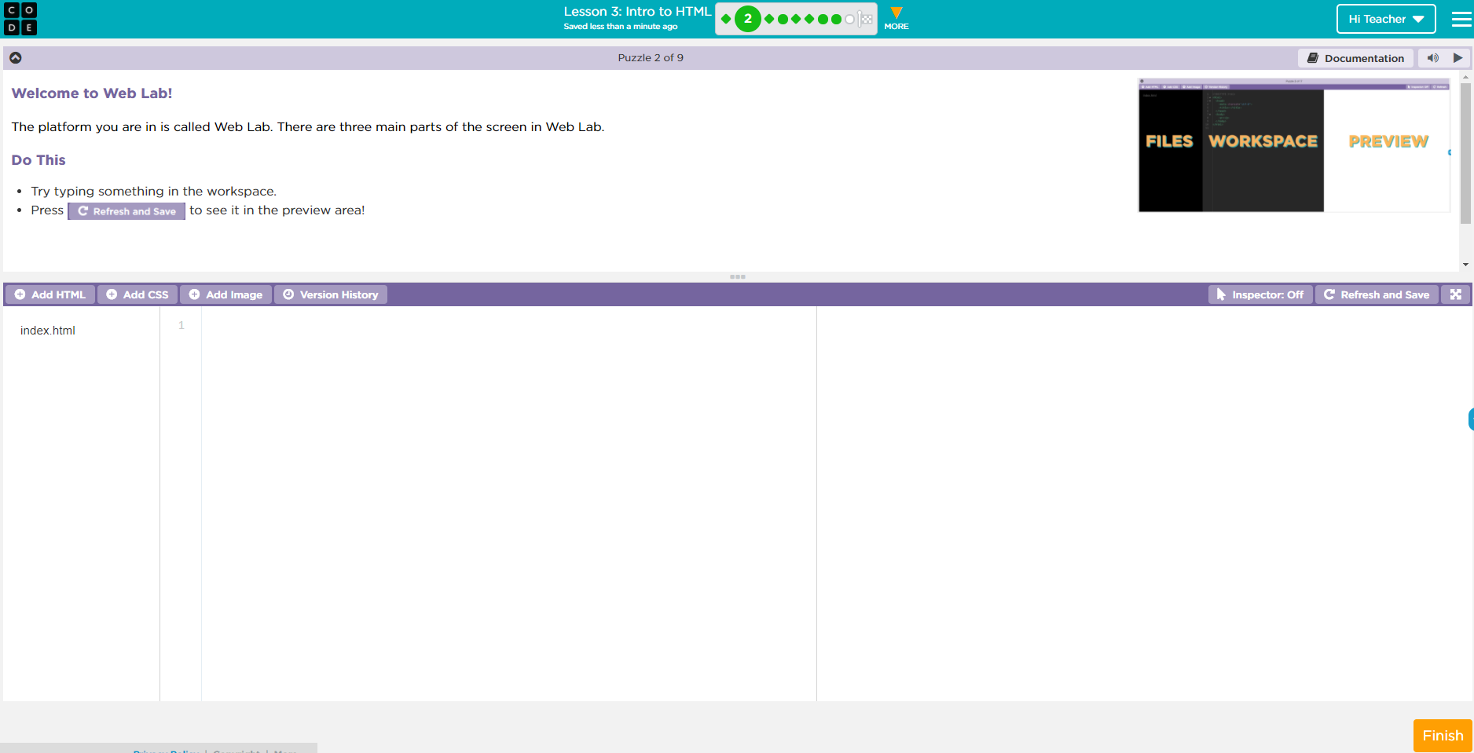
Class codes: Grade 7 XXGPRX
Grade 8 SGLFTT

