UNIT
4

Day #18: Rock-Paper-Scissors

Overview  Before students tackle the Rock-Paper-Scissors game on their own, we will practice using variables and conditionals as a group while reviewing the binary lessons from Unit 2. This lesson is a modification of a Scratch tutorial from https://ajstory.wordpress.com/2012/11/05/scratch-tutorial-dont-worry-its-easy/.  Lesson Summary  - Entry Task: Turn to your table partner and remind them how high you can count on one hand and why.  - Task #1: Review Binary  - Have students discuss their answers to the entry task.  - Task #2: Scratch Lesson  - Have students pull out “When flag clicked” and “Ask __ and wait.”  - We want to ask the user to input an 8 digit binary number to be converted into a decimal number.  - Task #3: Set the Variable  - Click on “Data” and “Make a Variable”.  - Our variable is “decimal.”  - Task #4: Create the Conditionals  - Pull out the “If, then” block and the = operator.  - Place the “letter 1 of world” block inside the left portion of the = operator and set the right side to 1.  - Replace the word “world” with the “answer” block.  - Use the “change decimal by 1” block for the “then” statement.  - Replace 1 with 128.  - Duplicate the entire block 7 times and increase the letter number by 1 while cutting the change number in ½.  - Task #5: Finalize the Program  - End the program with a “say __ for 5 secs” block.  - Use “join” blocks to create the output for your answer.  - Add a “forever” block around the entire thing and reset the decimal to 0 before asking the player for input.  CS Content  In addition to reviewing binary, this activity reminds students of the Problem Solving unit. It’s too easy for them to forget and give up, so this quick project helps them remember before tackling a more challenging assignment in the Rock-Paper-Scissors game. |  |  | Objectives  Students will be able to:  - Create a variable.  - Use an operator in a conditional.  - Set conditionals to add numbers to the variable.  Materials and Prep  - Complete the activity on your own so you can walk the kids through it as a group.  - See solution on next page.  Resources  Student Documents  Websites  - Scratch  Assessments  Notes

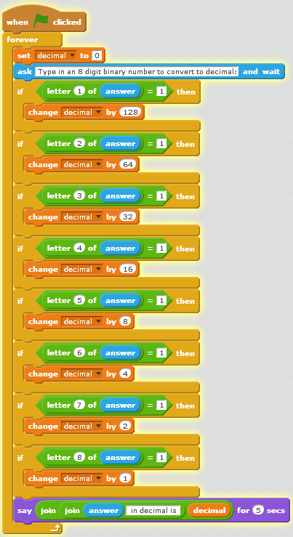
Would love to know if there is an easier way to do this!

