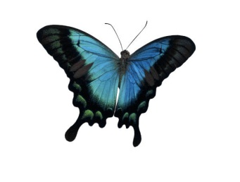
Fun Day

Create a new folder in your “h” drive titled “butterflys”
Start a new notepad document.
Tell “Mr. Computer” that you are going to use CSS
<style type=”text/css”>

Inside the head -Create rules for the following:
Body {margin-left: 50pt; margin-right: 50 pt;}

H2

P.middle {border-style: background-color: }

A {
text-decoration: underline;
Font-family: verdana;
Font-size: 12pt;
Color: blue; }
A:hover {
background: red;
color: white; }

Make sure you </style> before exiting the head.

In the body – Compose three paragraphs about Butterflys. Go out onto the internet and capture two pictures of butterflys and save in your folder next to this page.

Make the background color of the page cornflower blue, and using the font chiller. Enlarge the font to 19 pt.

In your paragraphs make the font size be 17 pt. . Have the paragraphs be indented 20 pts.
Let’s create a margin on both sides to be 50 pts.

In the middle paragraph place a thick, dashed, brown borders around the edges, and color the paragraph some light color.
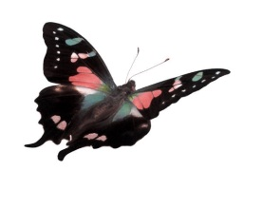
Place one image at the top of your page on the left side. Place the second image at the bottom of your page on the lower right side. Make sure both of these pictures have a dotted, brown border around the perimeter of the image.

Create a link to a web site for more information on butterflys. Hover the link from brown to yellow.

Make sure to save your document/web page as Butterflys.html

