CSP Practice With Loops

- Why do these create infinite loops?
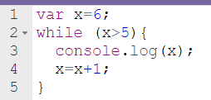
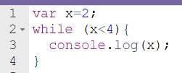
- b.

2. What will be displayed?
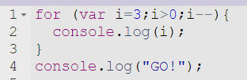

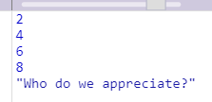
3.
- Write code using a for loop to display the following message.

- Write code using a while loop to create the same output.

4. 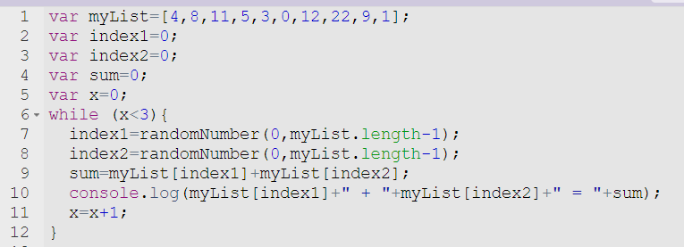

- How many times will the code run?

- Explain in words what will happen in this program.

- Give an example of what would be displayed in the console log.

NOTE: To determine if a number is divisible by 3, the remainder when you divide should be 0. The % is the symbol used for division remainder.
If x=12….. Code I could use is: if (x%3==0) { console.log(“The number is divisible by 3”)}
I could run thru a list of numbers and find how many are divisible by 3 by checking to see if num%3==0

5. Write code that will check the numbers 0-50 and display ONLY the numbers that are divisible by 4. I also want a statement to tell me how many numbers total there were that were divisible by 4. Use either a for or while loop.

