CSP Practice with Lists

1.
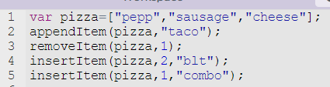

What would the list look like after this runs?
Check if you are correct by putting the code into App Lab on code.org
Go to code.org and start a new project in App Lab (click on your name, My Projects, Click on App Lab under New Projects
To see if you are correct, add this line to the end of the code and run it
console.log(pizza);

If you didn’t get the answer you thought, put console.log(pizza); after each line of code so that you can see what each line does to your list.

Write code to display the following information:
*I don’t want the answers. I want the line of code that would display each of these answers.*

The 3rd item in the list is: _____

There are a total of ___ items in the list

The last item in the list is ______

2. Given the following list:

What would this code display?
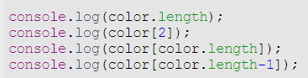

Write code to:

Add pink to the end of the list.

Remove white from the list.

Insert orange in between red and blue.

Check this by creating the code and adding console.log(color); after every line to see what is changing in the list

3. Given this list, write code to do the following:
*Think of these as individual commands. They are not done in succession.*

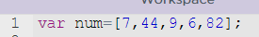

Remove the 7.

Add 37 to the end of the list.

Change the number in position 2 to a 14.

Add 103 so it is after the 9.

Display the list.

Display the length of the list.

Display the 4th number in the list.

Display the last number in the list.

Check this by creating the code and adding console.log(num); after every line to see what is changing in the list

