NAME ________________________________________ DATE ____________________ PERIOD _________

Unit 11, Section 1: Graphic Displays

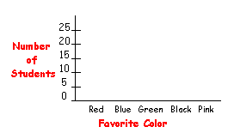

1. 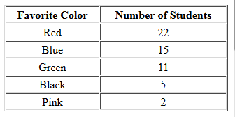 Complete the bar graph from the given data.

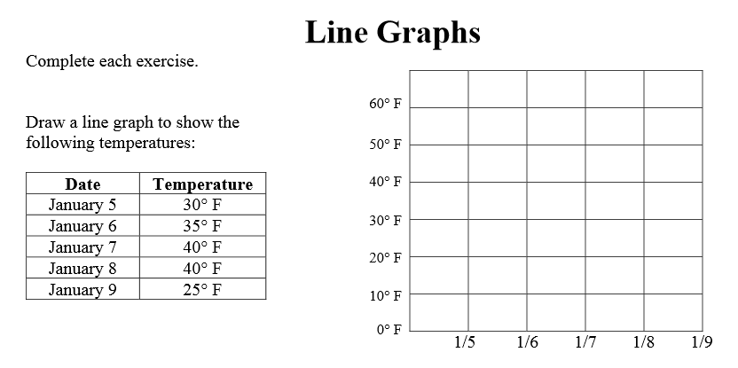


2. 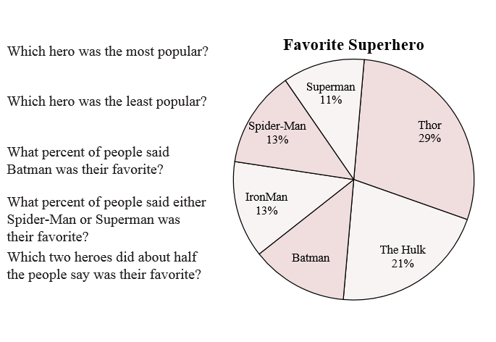Answer the following questions using the given pie chart.

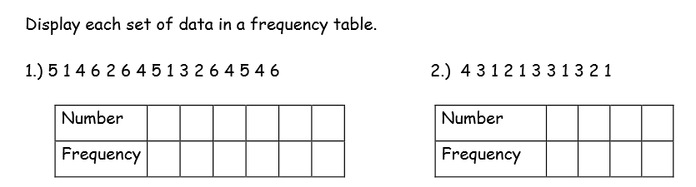Fill out the frequency table for each set of data. Then, make a dotplot.



1. 5)

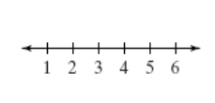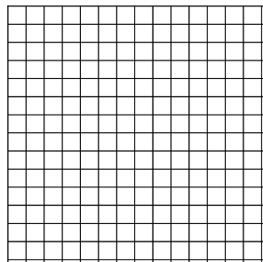

1. 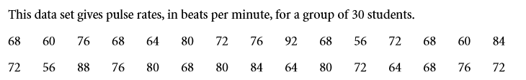Use tally marks to make a frequency distribution table for the data. Then, make a histogram.



50-59 60-69 70-79 80-89 90-99

Frequency