Circle the acceptable names for a variable:
4Halloween Halloween4 Halloween_4 Halloween 4 Hallow4een

What will be displayed in the console log?
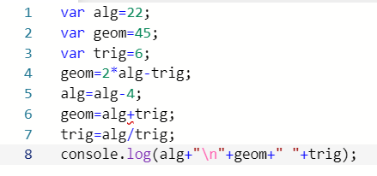
Console log:

What will be displayed in the console log?
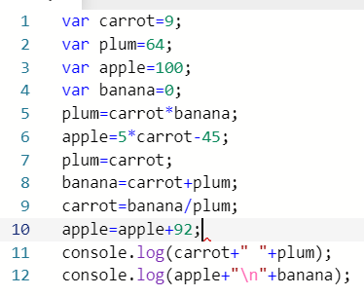
Console log:

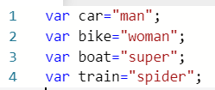
Write ONE line of code to display the following:

- spiderman

- super woman

- superstar

- I hate spiders

- man vs woman

- super man
spiderwoman

- superwoman+spiderman=
super team

