1.12 Personal Favicon Project
Objectives
- Encode a 16 x 16 or 32 x 32 image with at least 12 bits per pixel.
- Create and encode a color image of your own design.
- Describe image metadata and be able to use & manipulate binary numbers when describing colors.
Overview  A favicon is a small image that is typically shown in a web browser’s address bar next to the title of the page, in the tab of a web browser, or as an icon on a handheld device. A favicon for Code.org is shown to the right.  Favicons are designed by artists and programmed into web pages by web designers. Below are some examples of favicons—you might recognize some! | 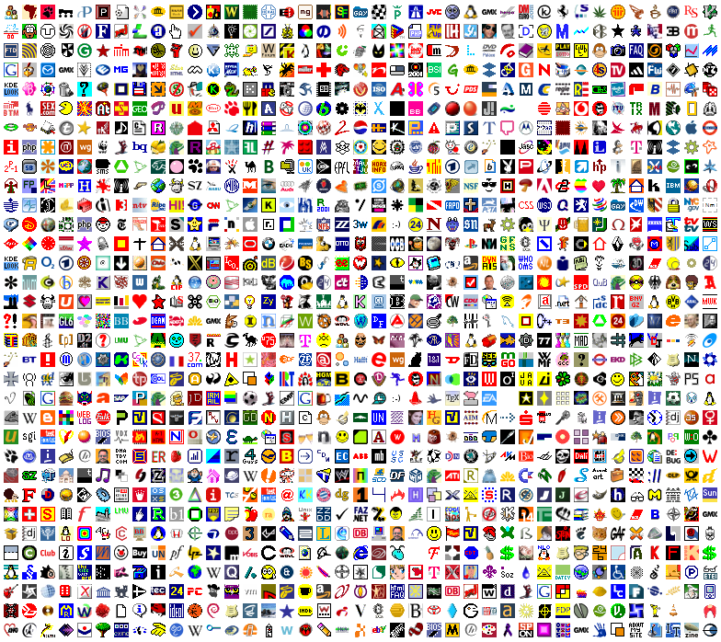

Directions
- Create a personal favicon and encode it using the Pixelation Widget on Code.org, note we are hacking a little so jumping to CSP 2019.
- The image you make should represent your personality in some distinctive way.
- Your image should be original and respect copyright.
- Your image must be encoded with either 12 or 24 bits per pixel
- Your image must be either 16 x 16 or 32 x 32 pixels.
  - Here are some past examples

Things to think about
- A simple design is probably the best solution, but several colors.
- This will be a very tiny image when you are done. Tiny details and slight variations in color probably won’t be noticeable. Use the “actual size” option to see what it really looks like.
- Plan ahead by sketching your design (preferably on a sheet of graph paper if you can) before starting to encode the bits.
Answer the questions below as part of your favicon project submission.

Favicon & reflection question
- Paste a screen snip of your completed favicon in the space below.
<answer here>
- Copy-and-paste all your favicon bit data in the space below.
<answer here>

- Explain the image in your favicon. Why did you choose this image? How is it a reflection of you?
<answer here>

- What copyright would you like your image to have? Are you willing to use creative commons copyright? Why?
<answer here>

Color Analysis
This might helpful: Flippy Do
- How many bits per pixel did you use? <answer here>
  - What was the range of possible red values? <answer here>
  - What was a benefit of using this many bits/pixel? <answer here>
  - What made this many bits/pixel challenging? <answer here>

- How many total bytes does your data contain? Explain/show the work that leads to this answer.
<answer here>

- Pick one color that appears in your favicon that does NOT have all 1s or all 0s in any of its three RGB channels.
  - Description/name of color: <answer here>
  - Binary representation of color: <answer here>
  - Binary representation of just red in 5b: <answer here>
  - Decimal representation of just red in 5b: <answer here>

Rubric
Standard | Exceeding | Meet | Approaching | Beginning
DAT-1.A - Represent with bits  Explain how data can be represented using bits. | A complete image that is 16x16 or 32x32 5 or more non-white/black colors used | A complete image that is 16x16 or 32x32 3 or more non-white/black colors used | A complete image that is at least 12 wide and 12 tall 3 or more non-white/black colors used | A partial image that is at least 8 wide and 8 tall 3 or more non-white/black colors used
DAT-1.C - Converting with Binary  For binary numbers: a. Calculate the binary (base 2) equivalent of a positive integer (base 10) and vice versa. b. Compare and order binary numbers. | Complete color analysis -All questions accurately answered with precision -Details used as appropriate to support work | Complete color analysis -Nearly all questions accurately answered with precision -Details used generally appropriate to support work | Mostly complete color analysis -Several questions accurately answered with precision -Details occasionally used to support work | Partial color analysis -Some questions accurately answered -Details occasionally used to support work
IOC-1.F - Legal and Ethical Concerns  Explain how the use of computing could raise legal and ethical concerns. | Image or theme is clear, and not from a copyright source. Creative Commons license is applied with reasoning | Image or theme is clear, and not from a copyright source. Creative Commons license is applied | Image or theme is vague, and not from a copyright source. Creative Commons license is applied | Image or theme is vague --OR-- Creative Commons license is not applied

