ANSWERS to More coding practice before U4L5-7 Quiz

- If you are 13 years old or older or if you are with a parent, you can get your ears pierced. Otherwise you cannot. Use age of 13 and no for a parent as a test (you can).
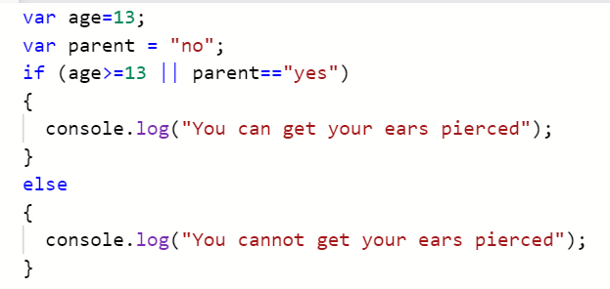

- If your favorite pet is a cat and your favorite food is pizza, we should hang out. Otherwise, find a new friend. Use favPet as dog and favFood as pizza as a test (find a new friend).
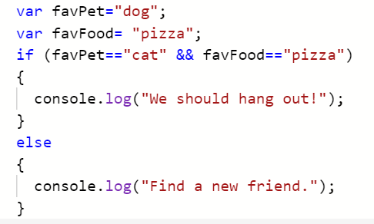

- If you missed 5 or more on your test, you have to come to 8th hour. If you missed 3 or 4 you have to redo your assignment. Anything less than that, you don’t have to do anything. Use a test where you missed 4 (redo your assignment).
