- Write a while loop to display the numbers 1-10

- Write a for loop to display the numbers 4-34, counting by 3s

- Write code using 2 different loops to display this message:

3
2
1
Spartans
Spartans
Spartans
Spartans

- What will be displayed?
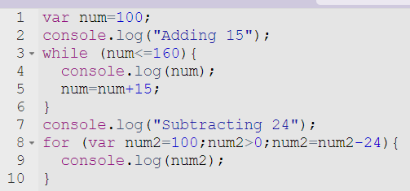

- Rewrite as a for loop
