CSP Unit 5 Lesson 11 and 12 Recap
- Write the code using a for loop to display the list of vegetables by traversing the list.
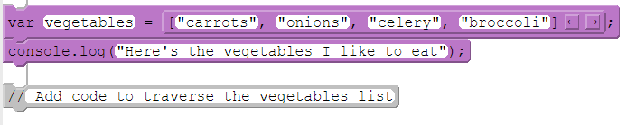

- What will be displayed?
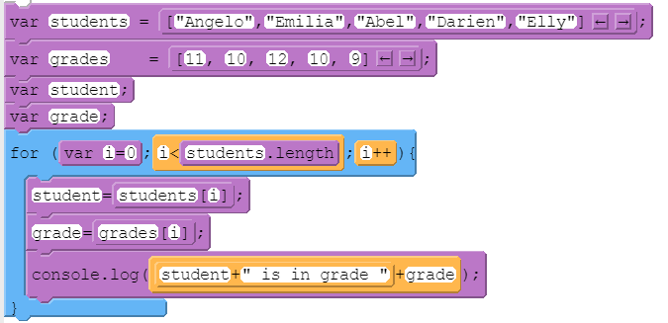

- What does this program do?
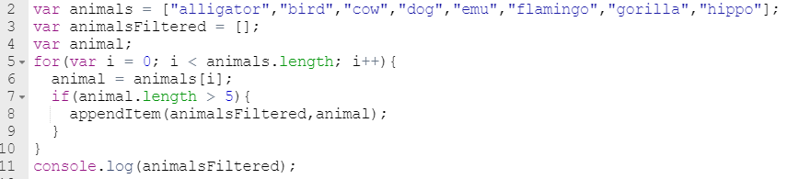

- Alter the code so that it finds the maximum prices (just cross off and write in the correct code- no need to recopy the entire thing).
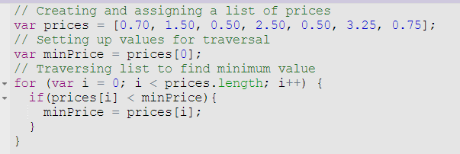

In your random forecaster app for Lesson 12,
- How many onEvents did you need for this app?
- What was it for?

- Where did you go to find the data table you needed in the app lab?
- Explain what this line of code is doing.

- Why did you have to filter your lists?

- Explain what this line of code is doing.
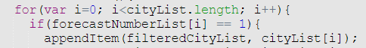

- What did we need a random number for in this program?

- Why did we use that random number in each setText statement instead of using a different one for each?

