Plotting Shapes #2
Directions: Color shapes (any color you choose) found at the bottom of this handout. Cut out the individual shapes and plot on grid according to coordinates provided. Refer to the Code.org website for assistance (Unit 3, Lesson 2).
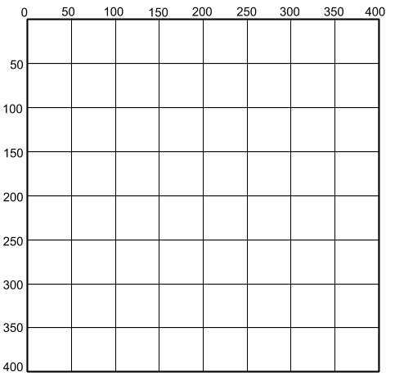
- Plot a SQUARE at (175, 175)
- Plot a CIRCLE at (150, 100)
- Plot a SQUARE at (75, 275)
- Plot a SQUARE at (225, 325)
- Plot a CIRCLE at (250, 100)
- Plot a SQUARE at (125, 325)
- Plot a SQUARE at (275, 275)
- Plot a SQUARE at (175, 325)

