Retake U4L3 Quiz
- Which names ARE acceptable for naming a variable? Circle them.

STUDY1more 1studymore study more study_more1

- What will be displayed in the console log?
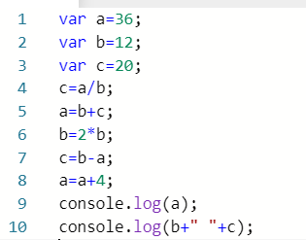
Console log:

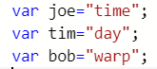

- Write ONE line of code to display the following in the console log:

  - daytime

  - do the time warp

  - time of day

  - warp day
time

