CSP Loops Quiz - ANSWERS

- Write code using a while loop to display the numbers 0-100 but counting by 5s (0 then 5 then 10…)

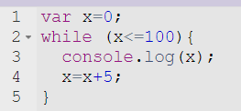

- Write code using a for loop to display the following message (Beatle’s song):
“Let it be”
“Let it be”
“Let it be”
“Let it be”
“Whisper words of wisdom, let it be”
*Note: the final line will not be part of the loop*

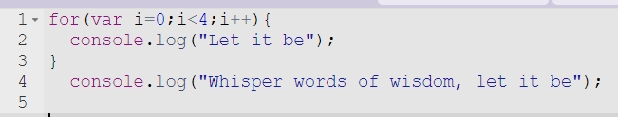

- What will be displayed?

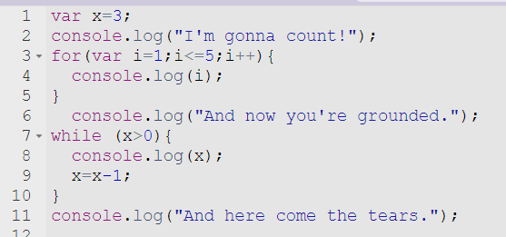
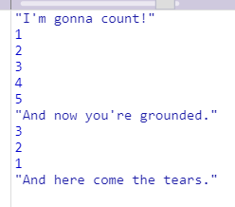

- What will be displayed?

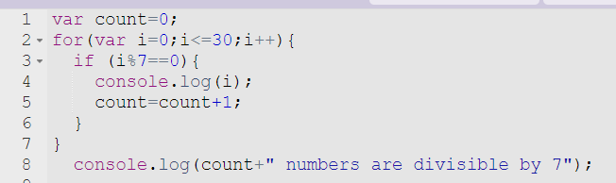

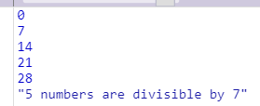

- Rewrite #4 using a while loop

