Create an app display similar to the one below.
- Users should be able to enter a number at the top and then click a button of their choice.
- The display at the bottom should update in the following way after each click:
  - If the new number after the calculation is even, it should display a message stating “Your new number is ___ which is an even number.”
  - Otherwise it should just state “Your new number is ___.”
- The number input box should clear out after a button is clicked.
- Ex.
  - Enter 5 and click Subtract.
  - Message states: Your new number is -5.
  - Enter 12 and click Add.
  - Message states: Your new number is 7.
  - Enter 4 and click Multiply.
  - Message states: Your new number is 28 which is an even number.
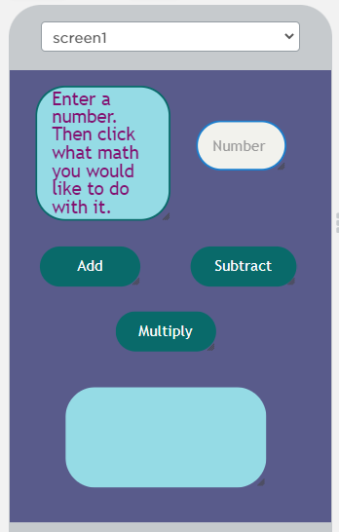
- Use a function for repeated code.

