NOTES: Unit 11, Section 1 Graphic Displays NAME ____________________________

Data Table and Bar Graph Data Table and Pie Chart
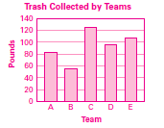
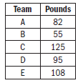
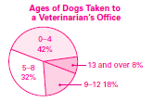
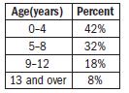

Date Table and Line Graph Dotplot Histogram
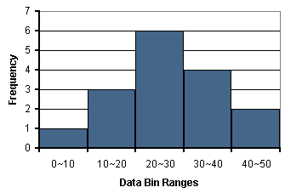
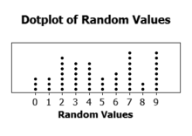
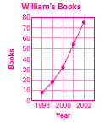
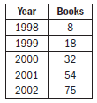

Frequency Distribution Table
Test Grade | Frequency
50 – 59 | 2
60 – 69 | 2
70 – 79 | 5
80 – 89 | 8
90 – 99 | 3
100 – 109 | 1

Quantitative and Categorical Variables
Quantitative Variable: takes numerical values for which arithmetic operations such as adding and averaging make sense. Examples: cholesterol levels, salaries, numerical test grades, etc.
Categorical Variable: places an individual into one of several groups or categories. Examples: car color, gender, zip code, drink size, etc.

