- Write a while loop to display the numbers 1-10
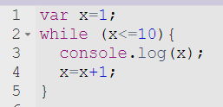

- Write a for loop to display the numbers 4-34, counting by 3s

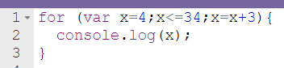
OR
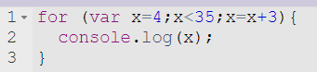

- Write code using 2 different loops to display this message:
3
2
1
Spartans
Spartans
Spartans
Spartans

Example solution (there are many ways to do this so ask me if you aren’t sure if yours will work)
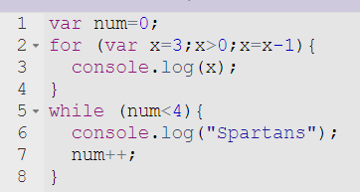

- What will be displayed?
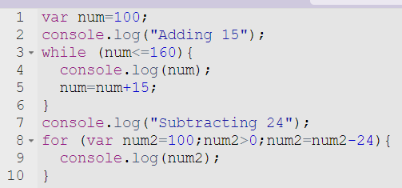

Adding 15
100
115
130
145
160
Subtracting 24
100
76
52
28
4

- Rewrite as a for loop
