U7 Lesson 4 – Extra Practice

APP 1: SIGN LANGUAGE QUIZ
This app allows the user to test their knowledge of the sign language alphabet. The user enter a text guess based on the image. Then an output of a smiley or frowny face is shown. If the answer is incorrect the correct answer is given.
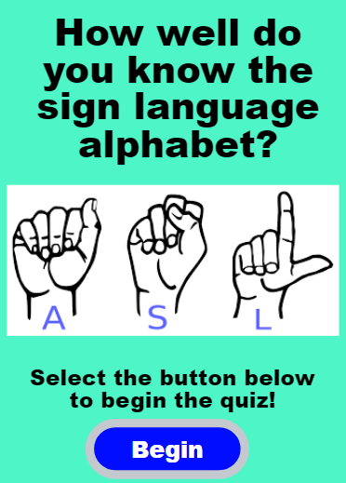 | 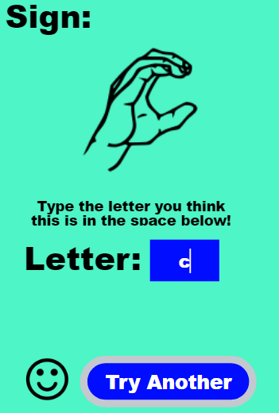 | 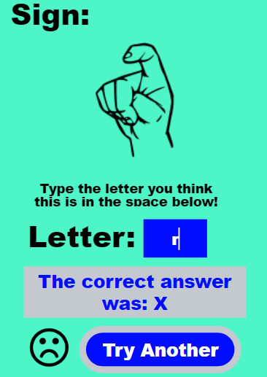

The code is shown below. Determine how to edit the checkAnswer function to integrate a parameter so that selection global variable is not necessary.
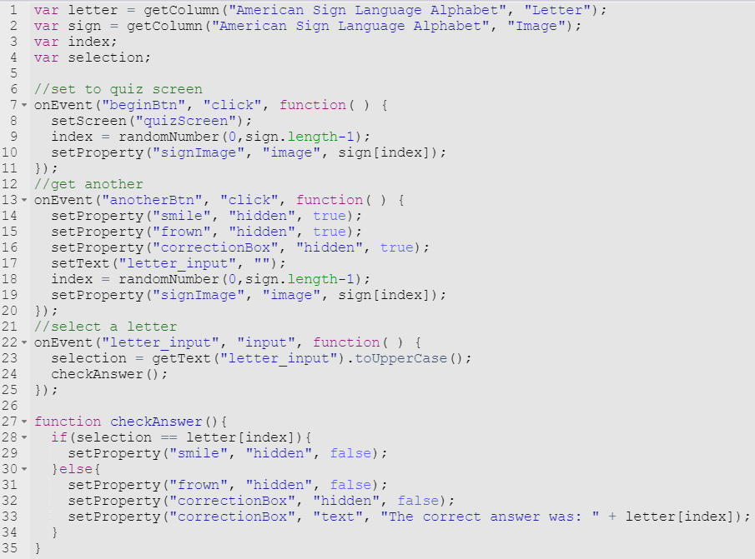

APP 2: THE FORECASTER
Remember the forecaster app? When we made the app we limited the forecast to the next day. However, the database has the forecast for 1 to 5 days out. This version of the forecaster has a dropdown to select the number of days from today.
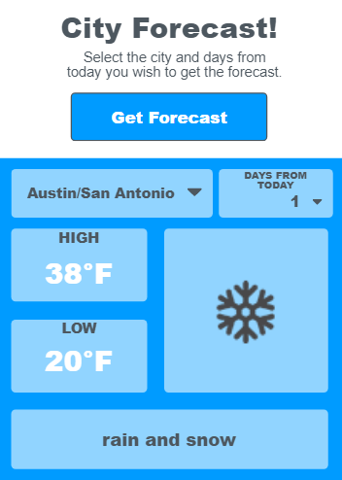 | 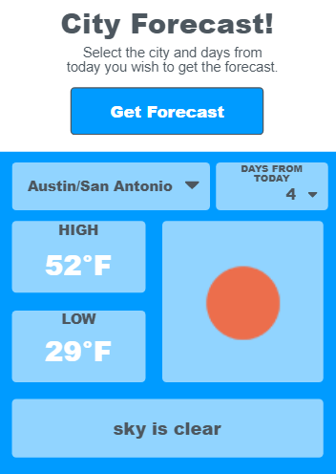 | 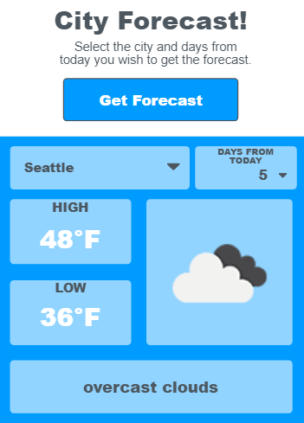

The code is shown below. Determine how to edit the filter function to integrate parameters so that the selectedCity and day global variables are not necessary.
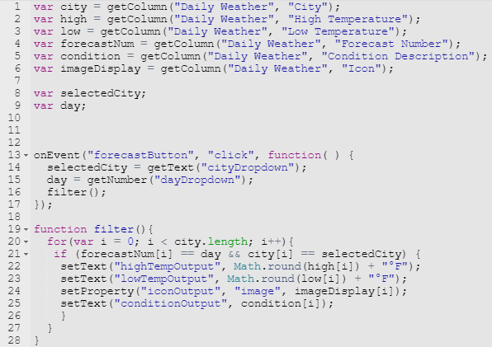

APP 3: NETFLIX RECOMMENDATIONS
This app allows the user to select a type of Netflix installment (Movie, TV Show or All) and a rating from two different dropdowns. On the final screen the recommendations based on the inputs are displayed.
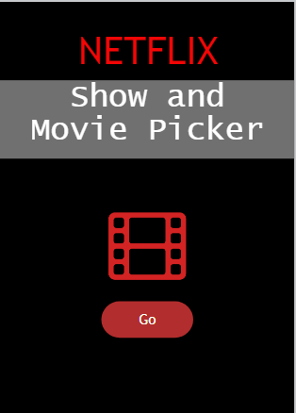 | 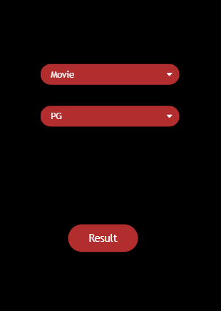 | 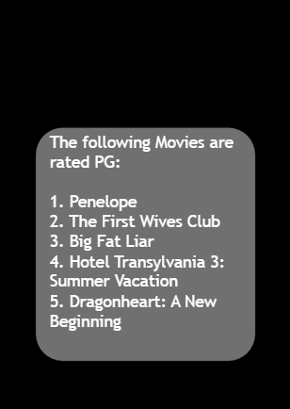
The code is shown below. Determine how to edit the searchTypeList function to integrate parameters so that fewer global variables are necessary.
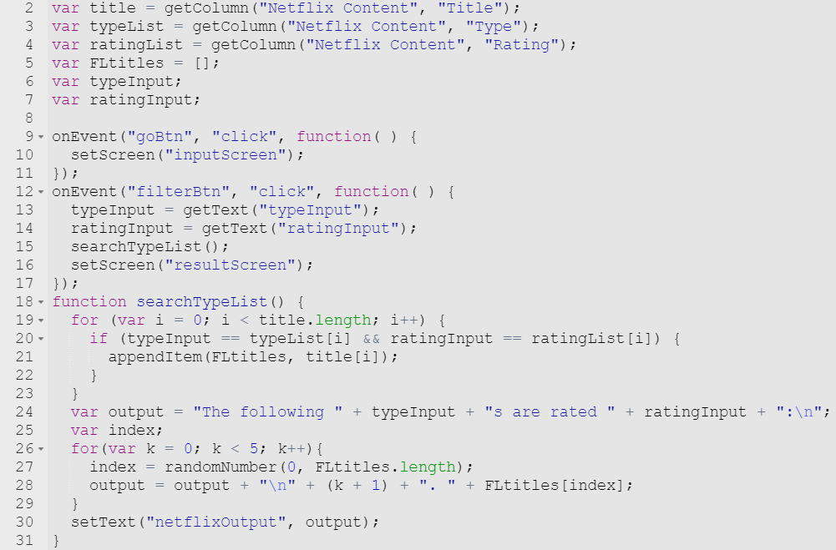

APP 4: PRESIDENTIAL INFO
This app allows the user to select either the name of a president of the number. Then, the next screen displays the information requested.
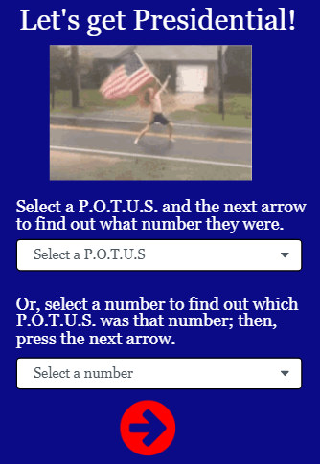 | 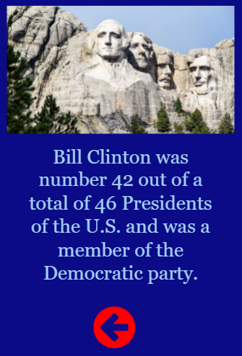 | 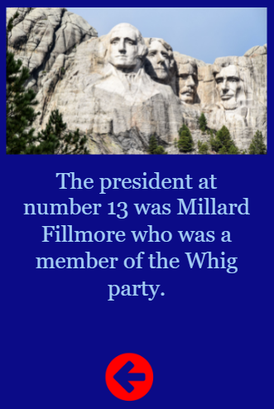

The code is shown below. This code has NO FUNCTIONS… you need to determine how to add function(s), parameter(s), and/or return(s) to manage complexity within this program.
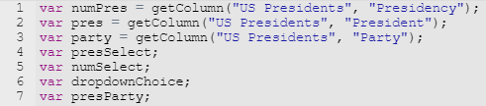

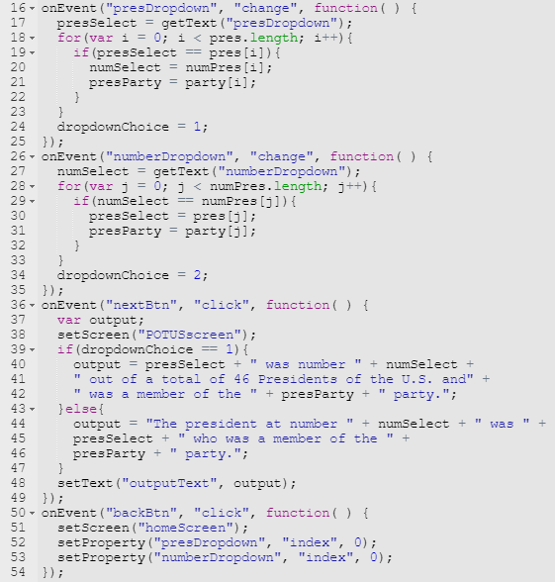

APP 5: DRINK ORDER
This app is for ordering and displaying drink orders for a barista. The first screen allows the barista to select a size and drink with the individual item total displayed. The final screen shows all drinks ordered and the total price.
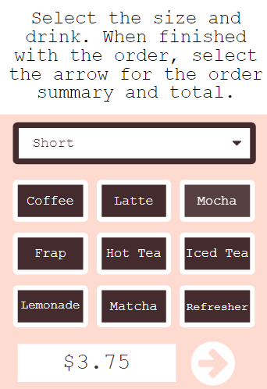 | 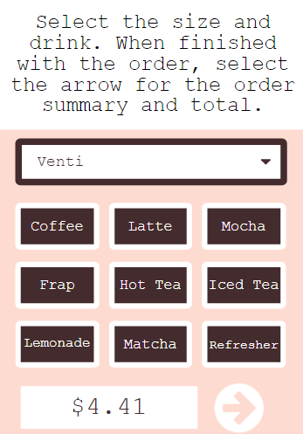 | 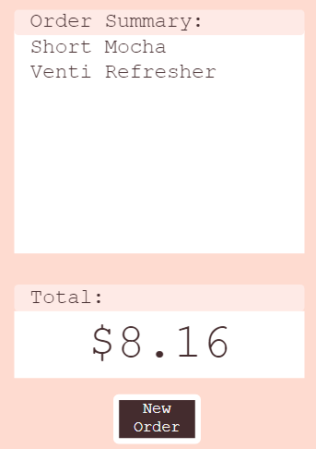

The code is shown below for just four of the buttons. This code has a function to increase the price based on the size; however, beyond that, there is far too much repetition. Determine how to rewrite this code using function(s), parameter(s), and/or return(s) to manage complexity.

