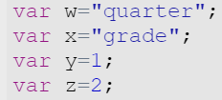

Use the variables above to display the following statements in the console log.

- My 1st quarter grade:
D

- Hopefully my quarter 2 grade is better

Fix this code.
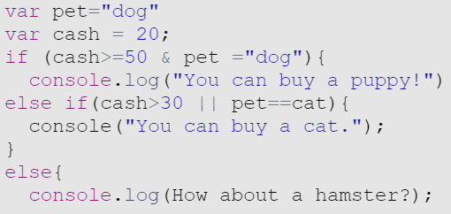

Once the code is fixed, what would be displayed if:

- pet = “dog” and cash = 25?
- pet = “cat” and cash = 20?
- pet = “dog” and cash = 50?
- pet = “cat” and cash = 60?
- pet = “dog” and cash = 30?
- pet = “bird” and cash = 35?

Answers:

- console.log("My "+y+"st "+w+" grade:\n"+"D");
- console.log("Hopefully my "+w+" "+z+" grade is better");

Fixed code:
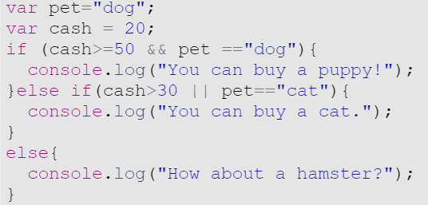
- Hamster
- Cat
- Dog
- Cat
- Hamster
- Cat

