CSP Practice with Strings and Substrings

- Given the string, what would be displayed:
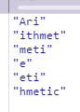
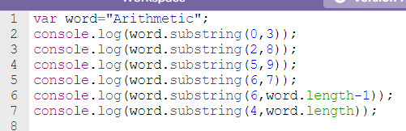

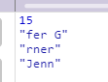
- Given the string, what would be displayed:
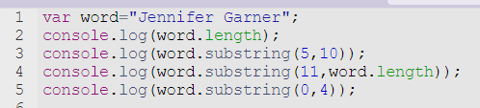

Write the code to display the following:

nnife
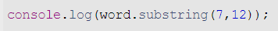

r Gar

Garner
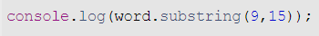
Or

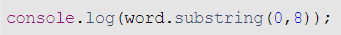

Jennifer

*How could you print her first name without knowing what it was?*

