Name _____________________________________________________ Date ____________ Period _________
Unit 3 Lesson 4 Using Simple Commands
A programming language is a _______________________________________________
_______________________________________________________________________ coding
Programming languages let humans___________________________________The language you use will depend on what you are trying to do. They all express ______________________.

A programming environment is a _________________________________________________.

JavaScript is used to make interactive websites and mobile apps

APP Lab
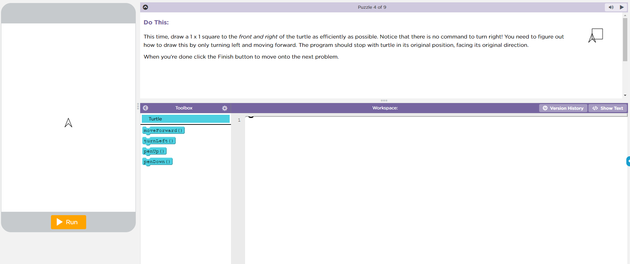
Where do you find your commands for the turtle?
Where do you put your commands for the turtle?
Where can you change how you add commands from text to block or block to text?
Where does your program run?
To add lines of code, you can ______________________ out from the tool box and ______________ them together, and then click ______________________ or if you prefer you can __________________________ yourself, and then click run.

