UNIT 2 - WEB DEVELOPMENT HTML Codes
On-line Resource https://www.w3schools.com/tags

Lesson 3: Intro to HTML
- <html></html> - the language your code is being written in
(Hypertext Markup Language)
- <!DOCTYPE html> - Tells the computer what language the page is written in (HTML)
- <p></p> - a paragraph may be set apart from other words on the page by spacing or indents
- <body></body> - the main words written on to the web page
- <head></head> - a subtopic .
- index.html – this is the home page of the website

Lesson 4: Headers
- <h1></h1> -headers are used to organize the main ideas of the web page. They come in 6 different sizes from h1 the biggest to h6 the smallest. These are found within <head>

Lesson 6: Lists
- <ul></ul> - unordered list – bullets not numbers
- <li></li> - this is needed before and after each group of words on the list
- <ol></ol> - ordered list – numbered list

Lesson 7: Intellectual Property and Images
- <img /> - does not need an opening and closing tag
The attribute “src” stands for source and tells the name of the image, and the attribute “alt” describes the image
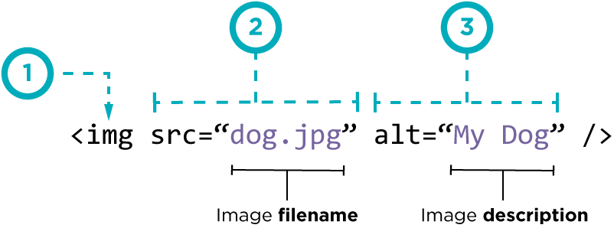

License Components

Icon |  | Description
 | BY | Attribution: Others who use this work must credit original author. The content author may specify how they would like credit given, but the attribution does not imply endorsement by the original author.
 | NC | Non-Commercial: Others may only use this work for non-commercial purposes. Commercial uses include selling products that use this content or using the content to promote commercial goods or services.
 | SA | Share-Alike: Users of this work must distribute any derivative works under the same license, including all the same restrictions.
 | ND | No Derivative Works: Users may only use this work as is and may make no modifications.

All CC licenses require users to attribute the creator of licensed material, unless the creator has waived that requirement, not supplied a name, or asked that her name be removed.

Additionally, you may satisfy the attribution requirement by providing a link to a place where the attribution information may be found.
Source :https://search.creativecommons.org/

Lesson 8: Clean Code and Debugging
- <!-- → - A comment -Comments can help you to debug, and will also help other people who are trying to understand your code.
- <title> - this is not part of the web page – it is the name. Your name choice could be important if you want others to be able to find your web page on the internet

Lesson 9: Project - Multi-Page Websites
- <a></a> - hyperlink – used to connect one web page to another. This is what you click on to change pages or link to somewhere else
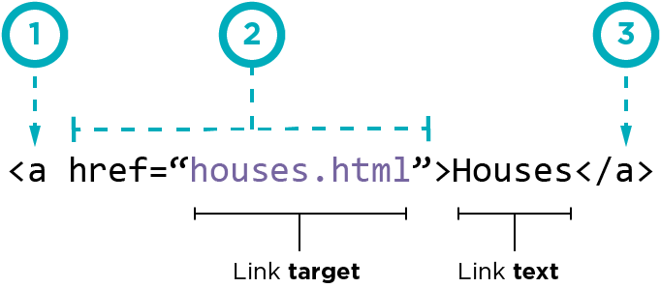
Link Target is where you want to go to Link Text is what it will say on the website
a-anchor href-Hyperlink reference

Lesson 9: Project - Multi-Page Websites
<footer>typically contains:
authorship information
copyright information
contact information
sitemap
back to top links
related documents

**Instructor Note – Before students share web pages, they should complete the CSS lessons to refine the look of the pages**

**Technical notes concerning the tags Head and Header**
The tag “head” is used in this course to define headers. That is not the typical use of the tag. This tag is meant to contain data to be read by the computer.
A header is information that is contained on multiple pages of a website such as navigation links. It's tag is “header”
See the following information from https://www.w3schools.com/tags
The following elements can go inside the <head> element:
- <title> (this element is required in an HTML document)
- <style>
- <base>
- <link>
- <meta>
- <script>
- <noscript>
<header>
- A <header> element typically contains:
- one or more heading elements (<h1> - <h6>)
- logo or icon
- authorship information

