Mrs. Fauble CSD Week of April 14 Lesson 7 (Intellectual Property and Images

Overview
This lesson covers how to use media such as images, video, or music created by others in a website while respecting the rights of the creator of that media. After first studying Creative Commons licensing, the class learns how to add images to web pages, and how to give proper attribution when doing so.

Vocab
- Citation - A quotation from or reference to a book, paper, or author, especially in a scholarly work.
- Copyright - the exclusive legal right to print, publish, perform, film, or record literary, artistic, or musical material, and to authorize others to do the same
- Creative Commons - A collection of public copyright licenses that enable the free distribution of an otherwise copyrighted work, used when an author wants to give people the right to share, use, and build upon a work that they have created
- Intellectual Property - A work or invention that is the result of creativity, such as a piece of writing or a design, to which one has rights and for which one may apply for a patent, copyright, trademark, etc.

New Code

<img>

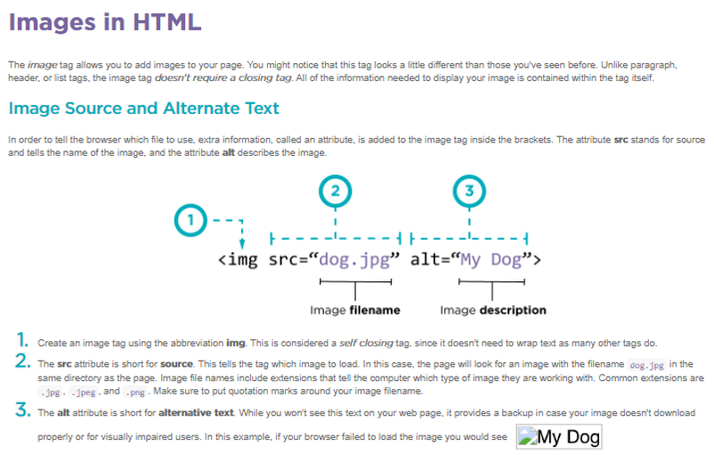

How do I add images?
The <img> tag allows you to show images on your web page.
Example:
<img src="dog.png" alt="dog jumping">
In order to tell the browser which file to use, extra information, called an attribute, is added to the tag inside the brackets. The attribute src stands for source and tell the name of the image. Image files names include extensions which tell the computer which type of image they are working with. Common extensions are .jpg, .jpeg, .png.
In addition to have the src attribute, image elements also have the alt attribute which describe the image. This is important in case the image doesn’t load or for people who have trouble with their eyesight.
An <img> tag is an example of a self-closing tag because it starts and closes in one tag.
Why does an image tag not have a closing tag?
An image tag doesn't need a closing tag because there is no text content which must be wrapped in tags. The content that shows on the screen is specified through the tags attributes.
What is an attribute?
Attributes are extra information included in a tag. Attributes have names and values. The name tells what type of information is being provided and then the value gives the specific information for that tag.
For example <img> tags have two attributes, src and alt. src specifies the name of the image file and alt tells the browser in readable text what the image is.

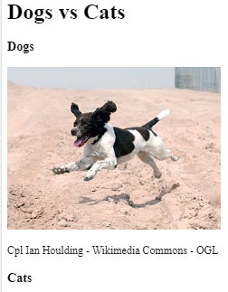
Images
A Dog vs Cat web page has been started for you. The dog image has already been added to the web page to the right. Look at the code that made the dog image appear, then use an image tag to add the cat.jpeg image to the page below the cat heading.
This image was found at pixabay and was uploaded by the user "Alexas_Fotos", who used a "free for commercial use" and "no attribution required" license.
Look at the code that made the dog image appear, then use image tag codes on lines 15 and 16 to add the cat.jpeg image to the page below the cat heading. Write the code in.

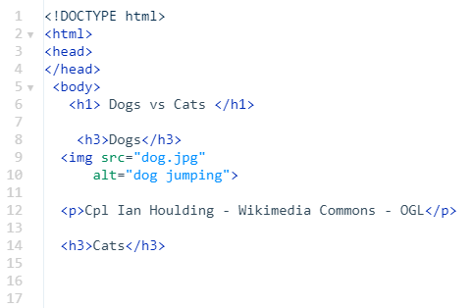

The Details Matter
The src attribute needs to point to the exact filename of the image you want to use. That means you need to pay attention to spelling, capitalization, and the file extension. Each of the three images on this page is broken because of an improper src attribute. Using the file menu for reference, fix each of the image tags.
Note: Even though the images are not loading properly, our website is still showing descriptive text of what should be there because we used alt attributes. Cool!

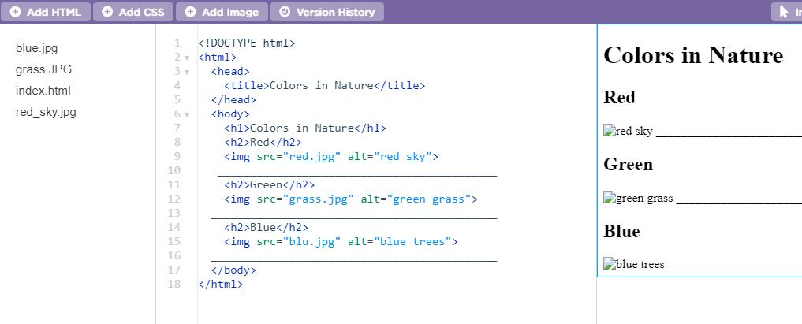
Look at the code carefully. The pictures aren’t showing because the “src” attributes are incorrect. Look at the file space to see the correct spelling and naming of each “src” attribute. On lines 10, 13, and 16 write the CORRECT code. Make sure your writing is legible!

HOMEWORK GRADE!!! Draw a line from the alt and src attribute mistakes on the left to the code on the left that it represents. The first one is done for you.

