Extension Activity
I chose to do Unit 5 Instructional Days 14-16 Bar Plots
The Plan
- Journal Entry— If everyone were going to be put in a different group based on the MONTH in which they were born, how many groups would there be? Which group do you think would have the most people?
- Participate in Birth Month Bar Plot Discussion
- Experiment with bar plot commands
- Public Agenda Bar Plot Activity
- Journal Entry
- Public Agenda data and mosaic Plots
- Wrap up Question
- Extension Activity
I decided to do an extension activity for this lesson. In this particular class, most of the students are not familiar with Google Charts or Microsoft Excel. I decided to challenge the students to use Microsoft Excel and have them create a bar chart and an exploding pie chart. The students have to figure out what information is needed in order to display the desired outcome. In this case the month and how many students birthday are in that particular month.
Reflection
This entire unit would make a great collaboration project. Some of the concepts are hard to understand even for myself. I had to go over this unit several times and it would have been nice to have a math or geography teacher to work with.
Advice for teachers
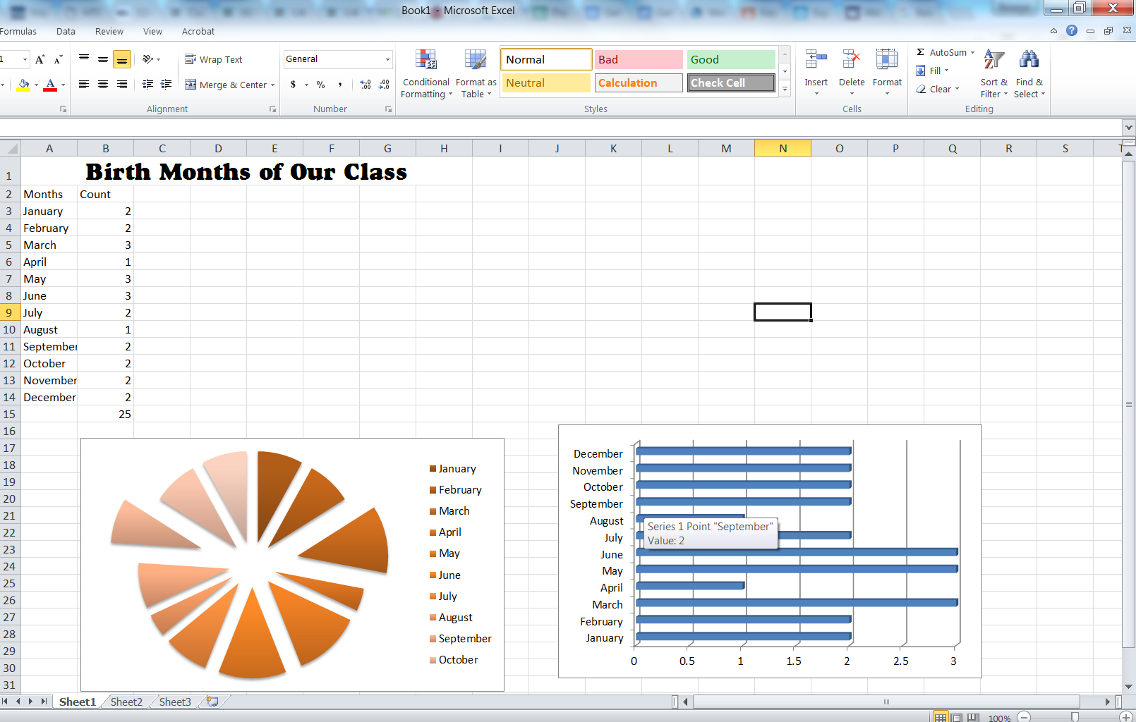
Plan, Plan, Plan! This is another lesson that should be planned ahead of time. For students who struggle, I would pair them up with a stronger student to make this activity enjoyable.

