CSP Practice with Lists

1.
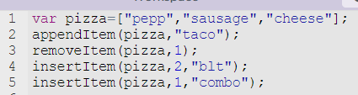

What would the list look like after this runs? [“pepp”,”combo”,”cheese”,”blt”,”taco”]
Check if you are correct by putting the code into App Lab on code.org
Go to code.org and start a new project in App Lab (click on your name, My Projects, Click on App Lab under New Projects
To see if you are correct, add this line to the end of the code and run it
console.log(pizza);

If you didn’t get the answer you thought, put console.log(pizza); after each line of code so that you can see what each line does to your list.

Write code to display the following:
The 3rd item in the list is: _____
There are a total of ___ items in the list
The last item in the list is ______

console.log("The 3rd in the list is: "+pizza[2]);
console.log("There are "+pizza.length+" types in this list");
console.log("The last type in the list is: "+pizza[pizza.length-1]);

2. Given the following list:

What would the following code display?
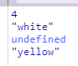
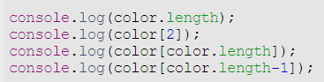
*The color.length is 4, but the last index is 3 (0-3), so that’s
why you get the undefined- there isn’t an index of 4

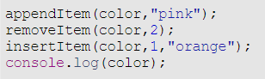
Write code to add pink to the end of the list
Write code to remove white from the list
Write code to insert orange in between red and blue

3. Given this list, write code to do the following:
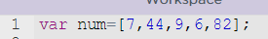

Remove the 7
Add 37 to the end of the list
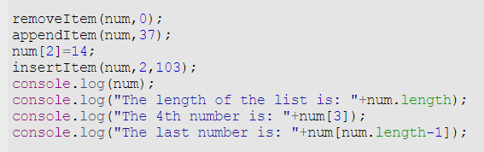
Change the number in position 2 to a 14
Add 103 so it is after the 9
Display the list
Display the length of the list
Display the 4th number in the list
Display the last number in the list

